**API Testing using POSTMAN**

**What is Postman?**

* Postman is a collaboration platform for API development that simplifies each stage of the API life cycle, from designing and testing APIs to monitoring and debugging them. It provides a user-friendly interface for building, testing, and documenting APIs, making it easier for developers to work APIs with features like collections, environment, automated testing, and team collaboration tools.

**Major Features of the Postman**

* **Collections:** Collection allows users to organize and group related API requests togethers. They provide a way to manage ,share,and execute sets of requests as a single unit.
* **Workspace:** Workspace in Postman are collaborative environments where teams can work together on API projects.
* **Request builder:** Postman offers an interface for building various types of HTTP requests, including GET, POST, PUT, DELETE, and more.
* **Environments:** Users can define environments with variables that can be used to customize requests for different scenarios.
* **Tests:** Postman provides a powerful testing framework that allows to write and run automated tests for APIs endpoints, allowing for testing without the need for the actual backend implementation.
* **Documentation:** Postman can automatically generate API documentation from collections, making it easy to share API specifications and usage instructions with others.
* **Monitoring:** Postman offers monitoring capabilities to track API performance, uptime, and response times

**What are cookies?**

* Cookies are small pieces of data that websites store on a user’s device, typically in the web browser, to remember information about the user’s interaction with the site.
* When you visit a website the site may send a cookie to your browser, which saves it on your device. This cookie contains information like your login credentials.

**What is Authentication?**

* Authentication is the process of verifying the identity of a user attempting to access a system, network or application
* When you log in to a website, authentication verifies that you are who you claim to be. You typically provide some form of credentials, such as a username and password.
* The system checks the credentials you provided against stored records to confirm your identity. If the credentials match authentication is successful, you are granted access to the system.
* **Types:**

**Basic Authentication:** Basic Authentication is a straightforward method where the user provides their username and password with each request the credentials are encoded. It’s simple to implement but less secure.

**Digest Authentication:** Digest Authentication is similar to basic authentication but adds a layer of security by hashing the credentials before sending them.

**OAuth (Open Authorization):** OAuth is an authentication framework that allows users to grand third party applications. OAuth uses access tokens, which are short -lived and specific to the permission granted by the user.

**HTTP Fundamentals**

* HTTP is an application layer protocol designed within the framework of the internet protocol
* HTTP involves communication between a client and a server. The client sends requests to the server, and the server sends back responses.
* **HTTP Methods:** Requests are made using different HTTP methods, which indicate the action the client wants to perform.
* **URLs:** URLs (Uniform Resource Locators) are used to identify resources on the web. They consist of a protocol (like HTTP), domain name, and optional path to the resource
* **Status Code:** After receiving a request, the server sends back a status code to indicate the outcome of the request. Common status code include:
* 200 OK – The request was successful.
* 404 Not Found – The requested resource was not found on the server.
* 500 Internal Server Error – There was an error on the server’s side**.**

**History :**

* In postman , the “History” tab keeps track of all the API requests you have sent. It provides a convenient way to revisit and reuse previous requests without having to manually re-enter all the details.

**What are params?**

* “Params” refers to the parameters that can be included in an API request. These parameters can be in the Request URL as a query parameter or in the request body.
* There are two types of parameters:

**1. Query Parameters**: These parameters are appended to the end of the URL and are separated from the base URL by a question mark(?). They consist of key-value pairs, where the key is the parameter name and the value is the parameter value

**2.Path parameter:** Path parameters are part of the URL path itself and are used to identify a specific resource or endpoint. They are typically denoted by placeholders in the URL path enclosed in curly braces{}.

**What are Headers?**

* Headers in Postman, like in any HTTP request ,provide additional information about the request or the client making the request. They consist of key value pairs and are included in the request to provide authentication credentials, or specify the format of the request and response.

**Common Headers:**

1.Postman Token

2. Authorization

3.Accept

4.User-Agent

**What is Body?**

* The “Body” refers to the payload or data that is sent along with an HTTP request. It typically contains information that the server needs to process the request,such as parameters for a POST or PUT request, or data to be updated or created. The body can be in various formats including JSON,XML,form-data,or raw text.
* In the Postman interface, you can customize the body of your request by selecting the appropriate format and providing the necessary data. Additionally, you can view the response body returned by the server after sending the request, helping you to verify that the request was processed correctly.

**What are Pre-request scripts?**

* Pre-request scripts in postman are like instructions you give to postman before it sends a request to a server. These instructions are written in a language called javaScript and can do things like adding extra information to your request like a token for authentication, or changing data based on certain conditions.

**What is a console?**

* The “Console” provides a log of all the network requests and responses made by Postman. It's like a record of all the communications between our computer and the server while testing APIs.
* The console helps you debug your requests and responses by displaying information such as request headers,response status code , and response bodies.
* **JSONPlaceholder** : JSONPlaceholder is a free online service that provides fake JSON data for testing purposes

**Dummy API using JSONPlaceholder:**

* We create a dummy API and test it using postman for different HTTP methods PUT,POST,GET,DELETE,AND UPDATE we can use various methods.
* **Step 1 - visit the JSONPlaceholder website :** JSONPlaceholder
* JSONPlaceholder provides endpoints for various resources like posts,comments,users etc.
* If we want to work with posts, we can use the ‘/posts’ endpoint.
* **Step 2 - We Test the API in postman:**
* **GET Request Example:**

1. Open Postman and create a new request.
2. Set the request method to GET
3. Enter the URL: ‘<http://jsonplaceholder.typicode.com/posts>’.
4. send the request
5. we should receive a list of dummy posts in the responses body

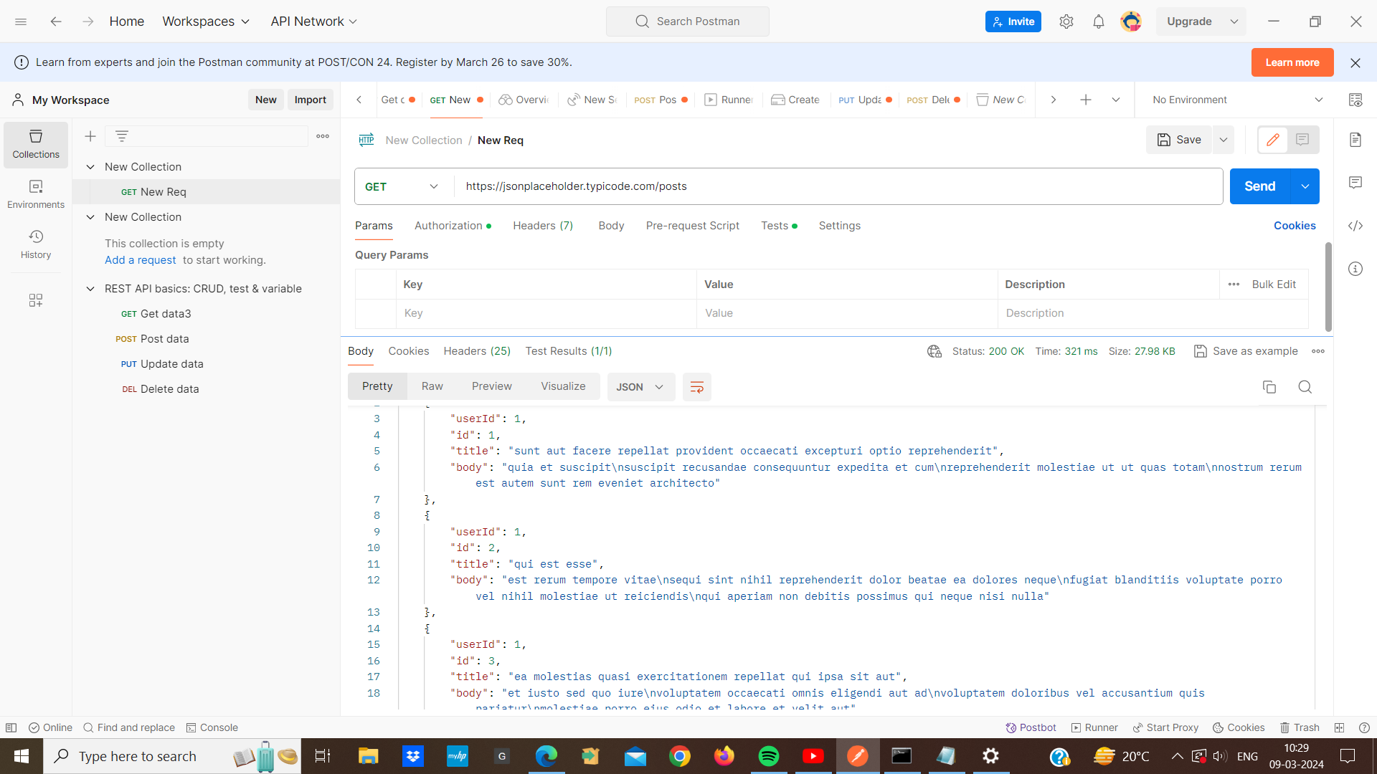

* **POST Request Example :**

1. Create another request in postman.
2. set the request method to POST.
3. Enter the URL:‘<http://jsonplaceholder.typicode.com/posts>’.
4. In the request body, add JSON data representing a new post
5. for example :

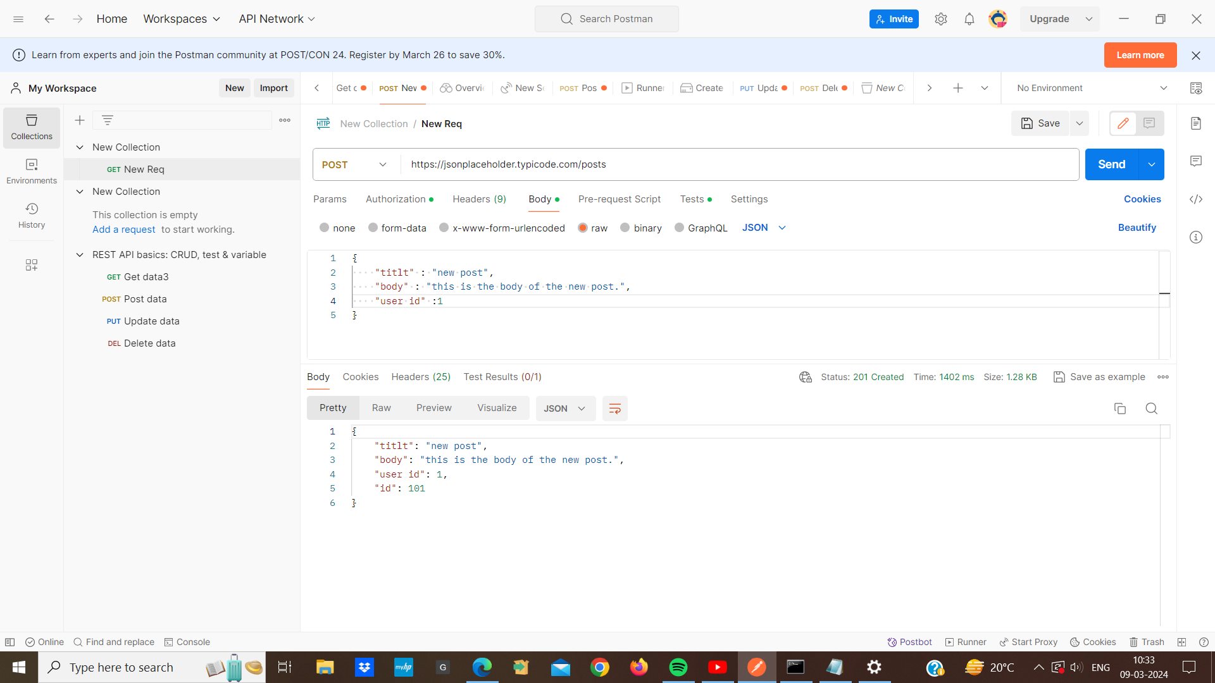

1. Send the request
2. we should receive a response containing the newly created post data.

**PUT request example :**

1. Create a PUT request in postman.
2. Enter the URL: [http://jsonplaceholder.typicode.com/posts/{postId](http://jsonplaceholder.typicode.com/posts/%7BpostId)} ,where {postId} is the id of the post we want to update.
3. In the request body we include the updated data for the post.
4. send the request and we should receive a response containing the updated post data

**DELETE request example:**

1. create a DELETE request in postman.
2. enter the URL [http://jsonplaceholder.typicode.com/posts/{postId](http://jsonplaceholder.typicode.com/posts/%7BpostId)} post id is the id of the post you want to delete.
3. Then we send a request and we should receive a success response indicating that the post has been deleted.

**Postman Variables And Postman Objects:**

* **Postman Variables:** These are like placeholders where we can store and change data as we run requests in postman.
* **variables can be classified into different types**

1. **environment variables :** Environment variables in postman are like placeholder for values that we can reuse across multiple requests

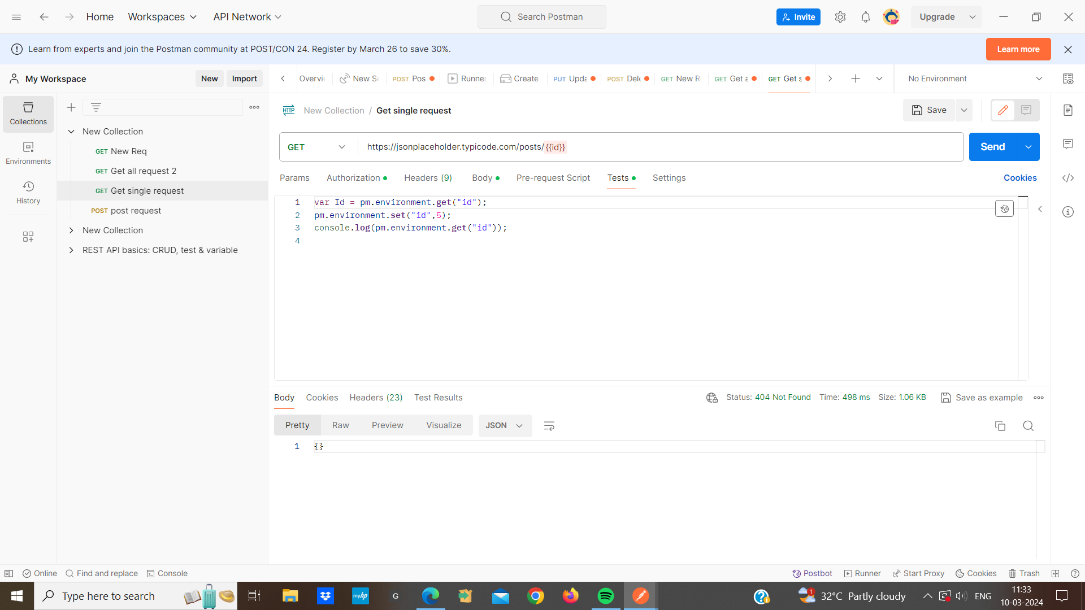

1. **global variables :**  A global variable is a variable, if we set it global,that means the global variable becomes the base URL.Then we can set the base URL to global , so our global variable will never change.It contains key value pairs.

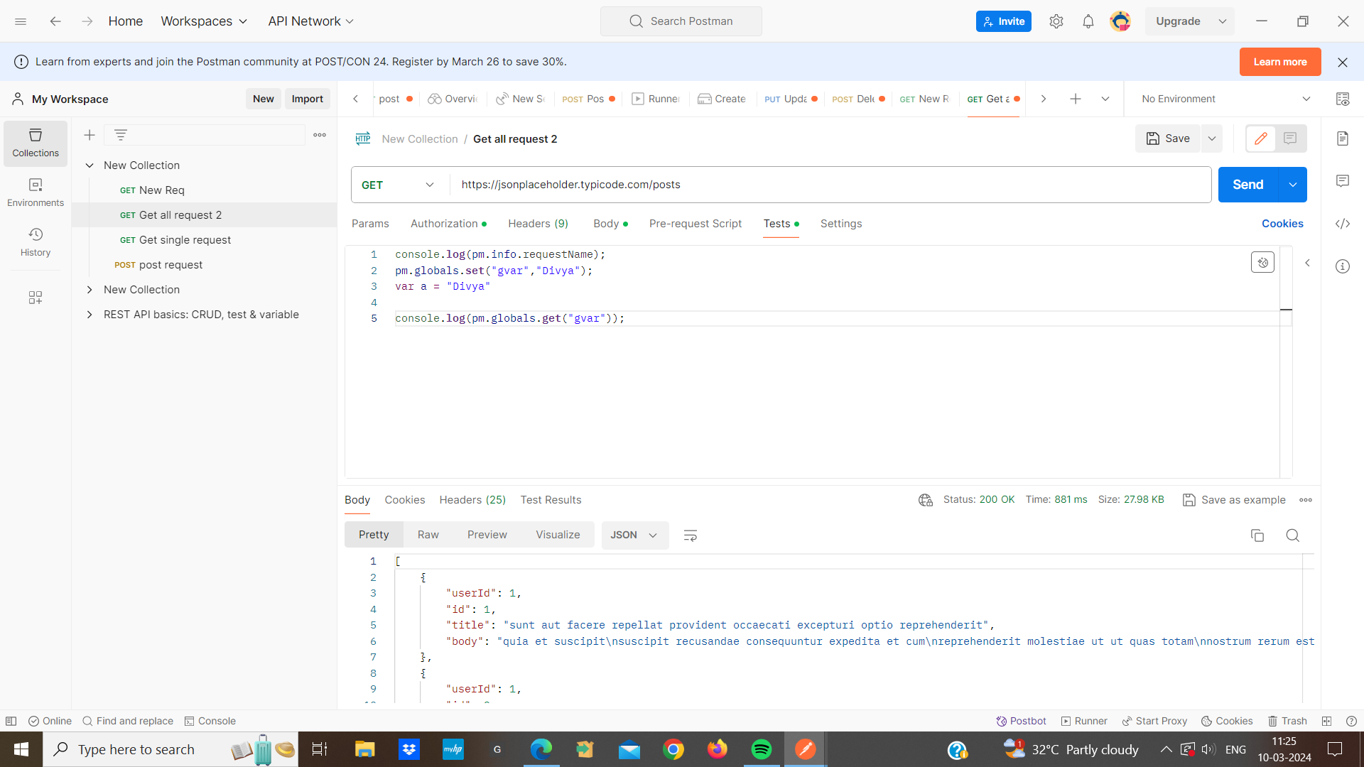

1. **collection variables :** These variables enable us to share data between requests within the same collection. At the collection level we can set the variable for example : a student collection and a person collection inside the student collection we put Ids from 1 to 100. This is a student collection . And in person we can start ids alphabetically from ABCD so in person ids can be anything else i.e Different . This is a collection variable.

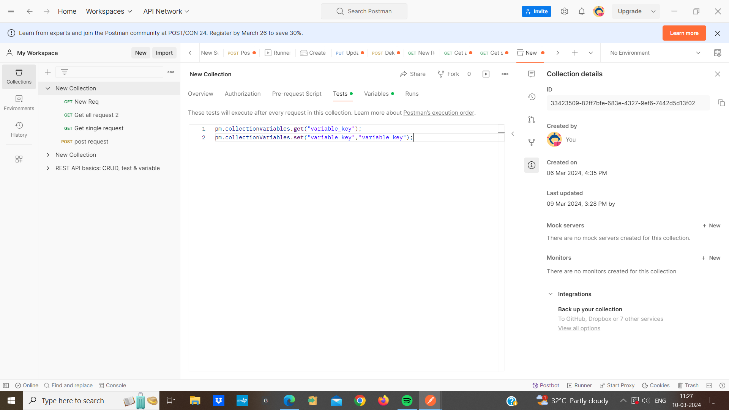

1. **Local variables :** These variables useful for storing data during script execution.A local is a locally that we normally create inside a tests
2. **Data variable :** Data variable used for storing and managing data during the execution of scripts or tests

* **Postman Objects :**

1. **pm.request():** pm.request object provides access to properties and functionalities related to the current being executed
2. **pm.response() :** pm.response offers access to properties and functionalities related to the response received from the server after sending a request ,such as response body and status code.
3. **pm.Environment() :** pm.environment allows interaction with environment variables, including setting ,getting,and updating during execution.
4. **pm.collection () :** pm.collection provides access to information about the current collection,including variables, requests,and folders .
5. **pm.data ()**: This enables storage and retrieval of data between requests and useful for sharing data across different parts of a collection run
6. **pm.info.requestname ():** pm.info.request name object gives request name in console

if i want to get the name of the request i use this request . This will return the name of the request currently being executed in the postman environment .

for ex:

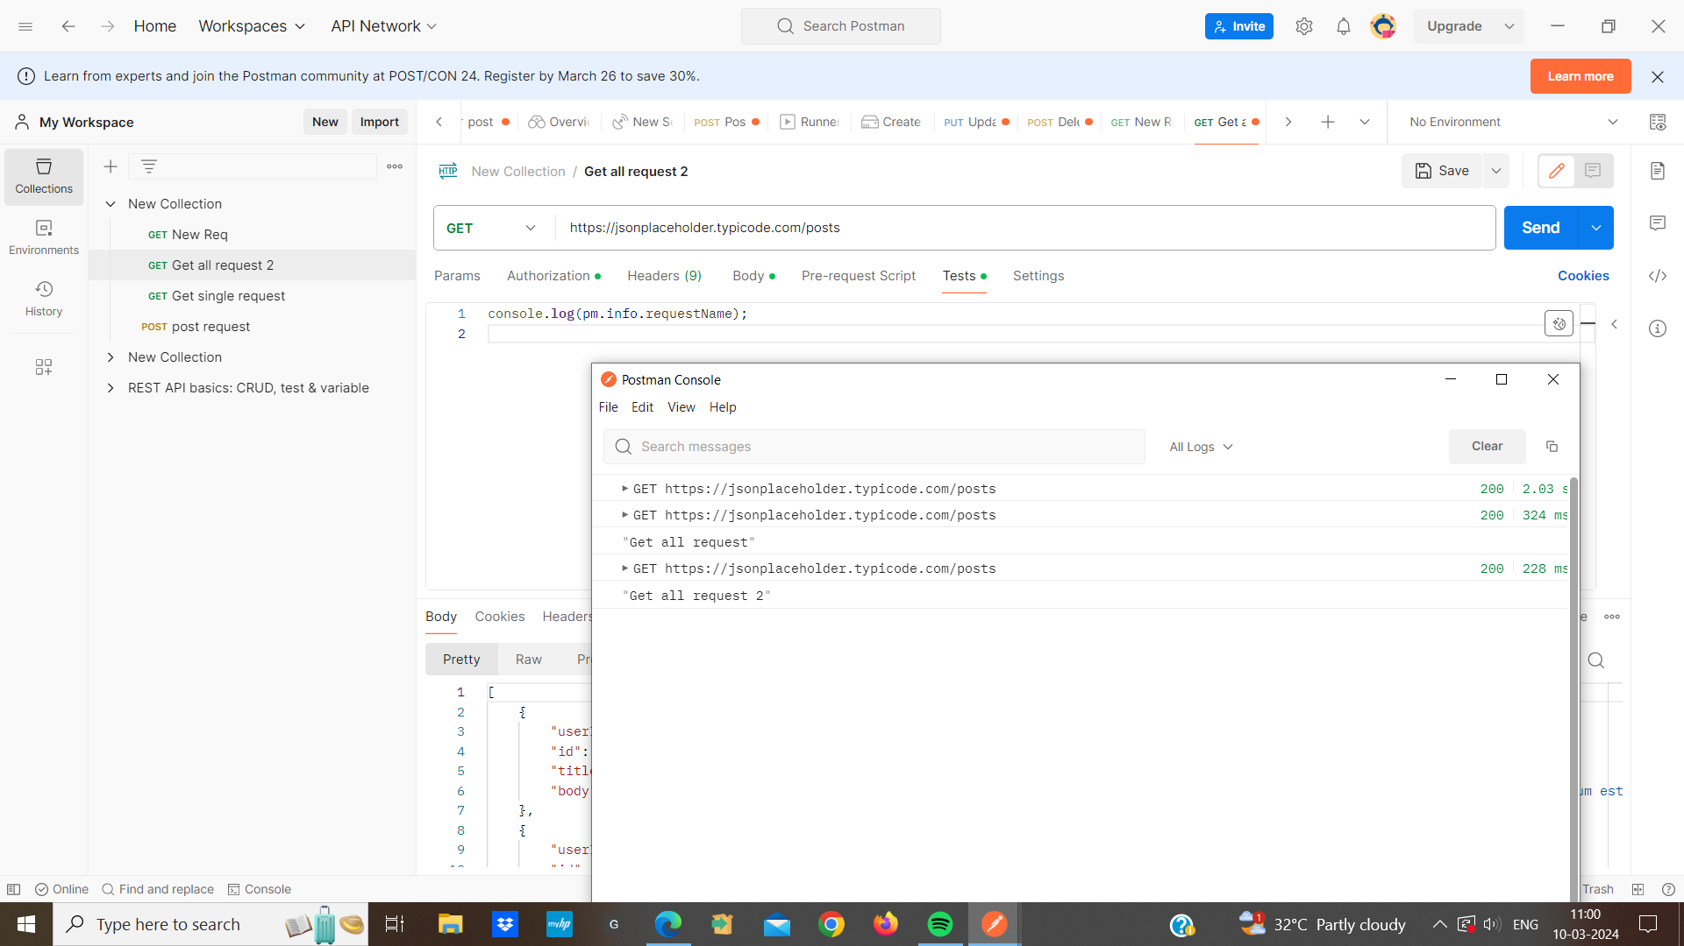

1. **pm.sendrequest ():** The pm.sendrequest() function is used to send an HTTP request. It allows us to programmatically send requests to APIs. we get the responses in it and we can write the test cases in it and also set variables.

**we upload file and send data in postman:**

1. First we create a new request and set the request method to ‘POST’.And enter the URL of the API endpoints where we want to upload the files and send data.
2. Add the necessary headers such as, ‘content -Type’.
3. Select the “form-data” option in the body tab.
4. Add a key-value pair for the upload and another key -value pair for the JSON data.
5. then we save our request and execute the request to upload file and send data

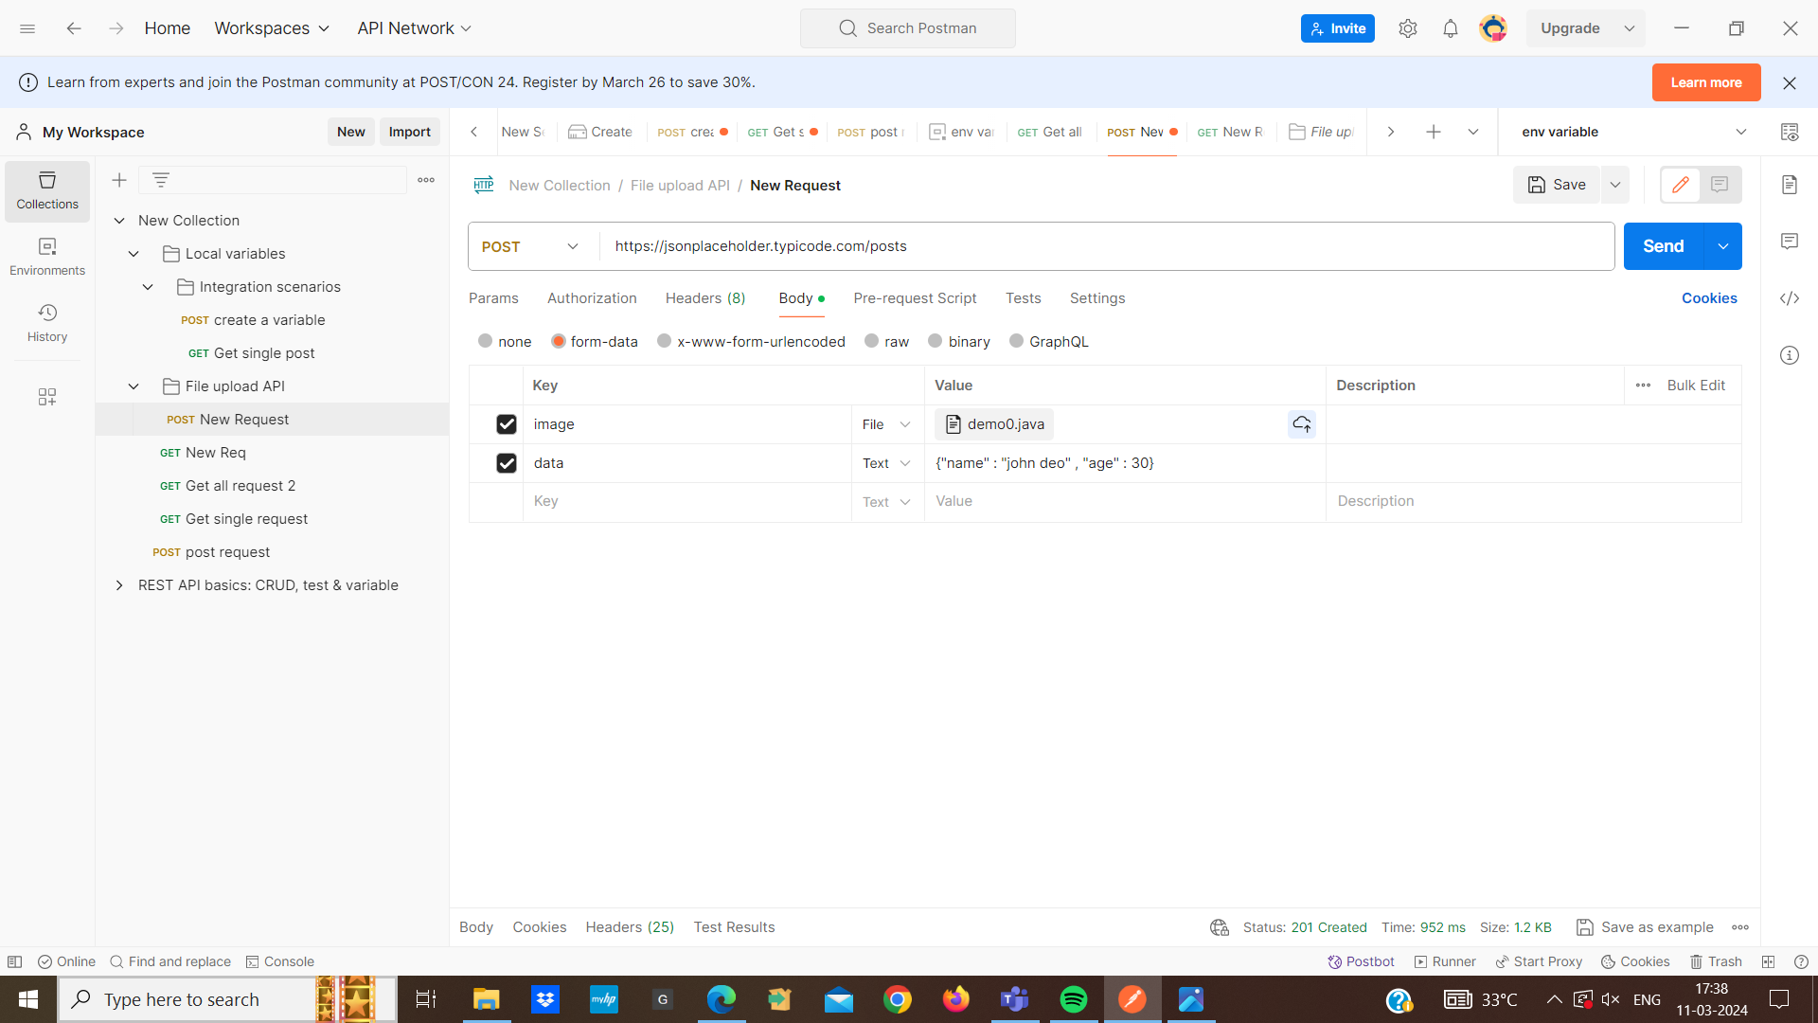

**JSON Schema Validator:** JSON Schema Validation is like having a set of rules for our JSON data. These rules define what the structure of our JSON should look like ,what type each piece of data should be. When we perform JSON schema validation, we are essentially checking whether our JSON data follows rules.

**Ajv(Another JSON Schema Validator):** Ajv is a popular library in the javascript used for validating JSON data against a JSON Schema. Json schema validation with Ajv involves a JSON schema acts as a blueprint specifying the structure, format for our JSON data

* we can put a schema validation in out tests so that the API tests we have created becomes robust
* We can do that testing well by using JSON schema validation with Ajv.
* By default there is a JSON schema validator named Tiny Validator in postman , but I am going to use the Ajv schema validator for it.
* Ajv schema validator is the fastest and checks very well.
* I have created a request in which i am giving information of user id, id, title, and body .When i send it . it returns me all the information so this is our response , so i have to validate it. the structure that is coming should be an object of JSON because it is an object .
* I will use Ajv to make a JSON schema . The best part is that we can import it directly in postman. i will import it then create its object then we need a schema.
* I will open two sites. The first is the JSON schema validator and the second is JSON Schema creator.
* I will create a JSON schema for our response.
* visit the Ajv JSON Schema Creator website and paste our response

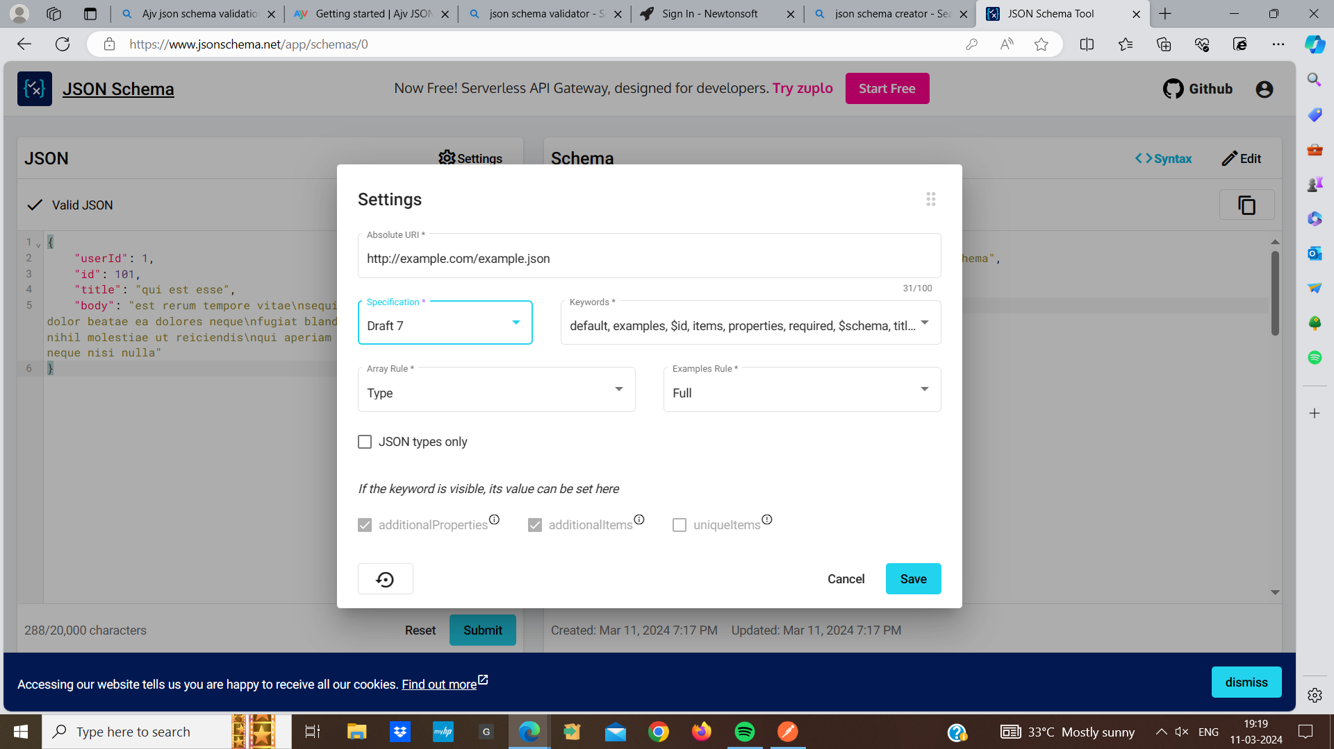

* i will use the specification draft 07 because it works well with draft -07

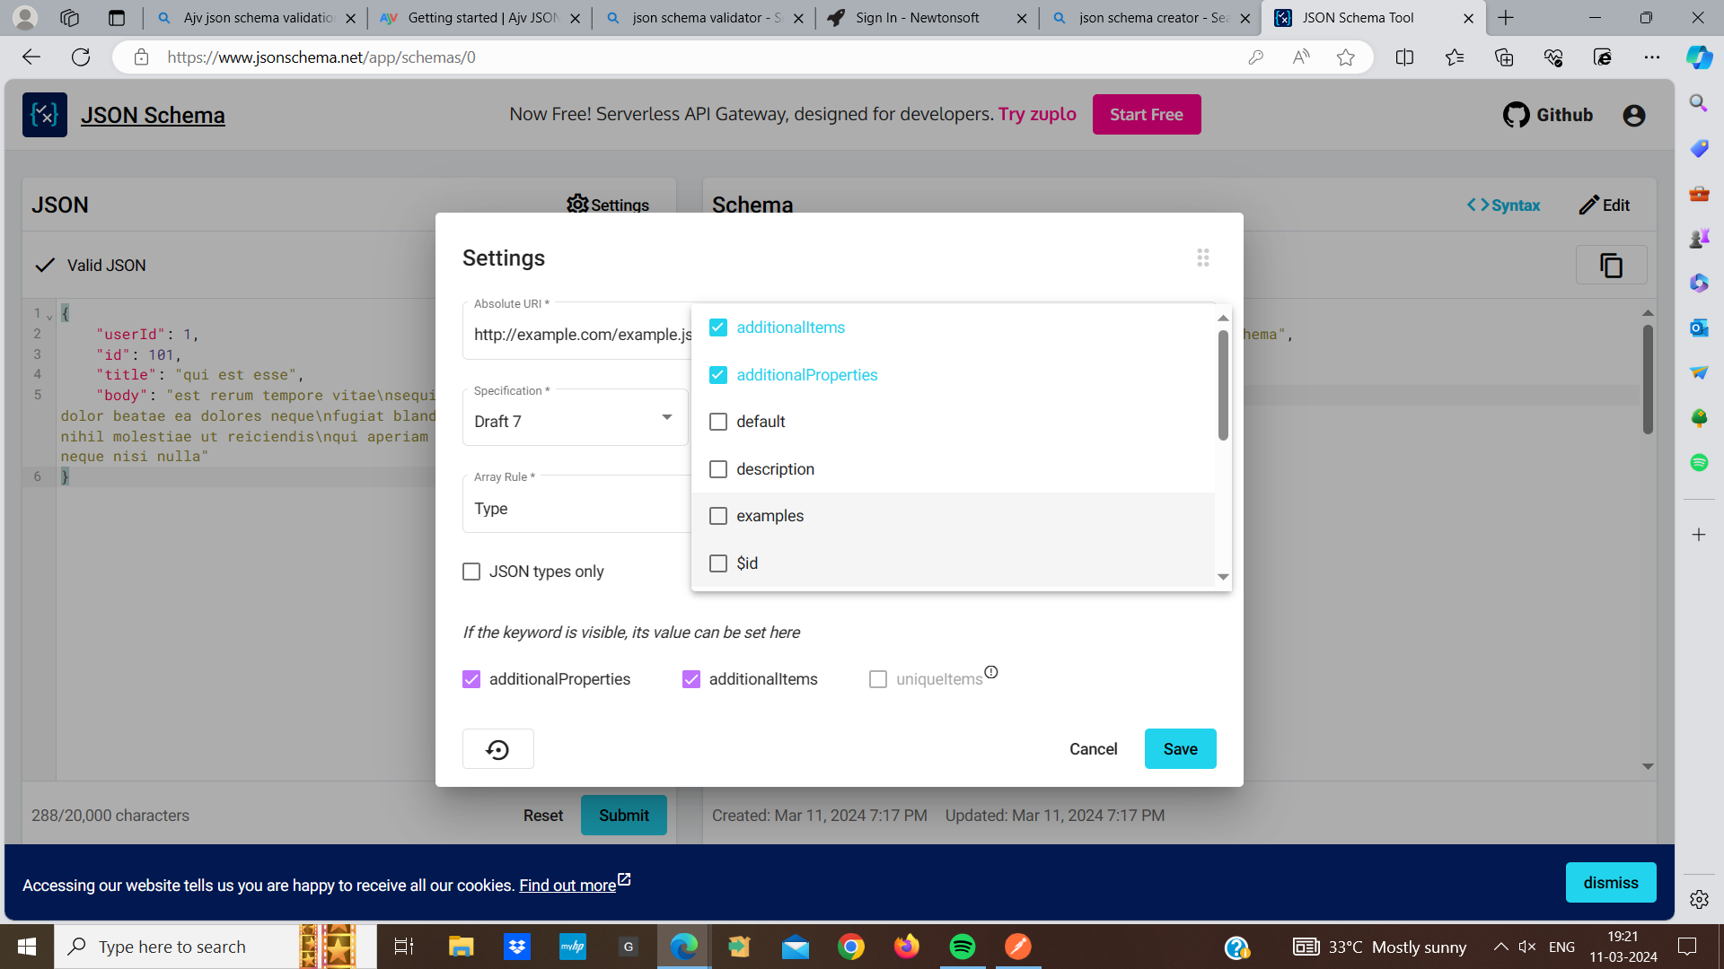

* click on the generated schema and copy the generated JSON schema code to our clipboard
* Visit the Ajv JSON schema validator website
* I will paste the JSON schema code I copied from the AJV JSON schema creator into the validator.
* click on the “validate” button to validate our JSON data against the schema.
* Review the validation results to ensure that our data conforms to schema

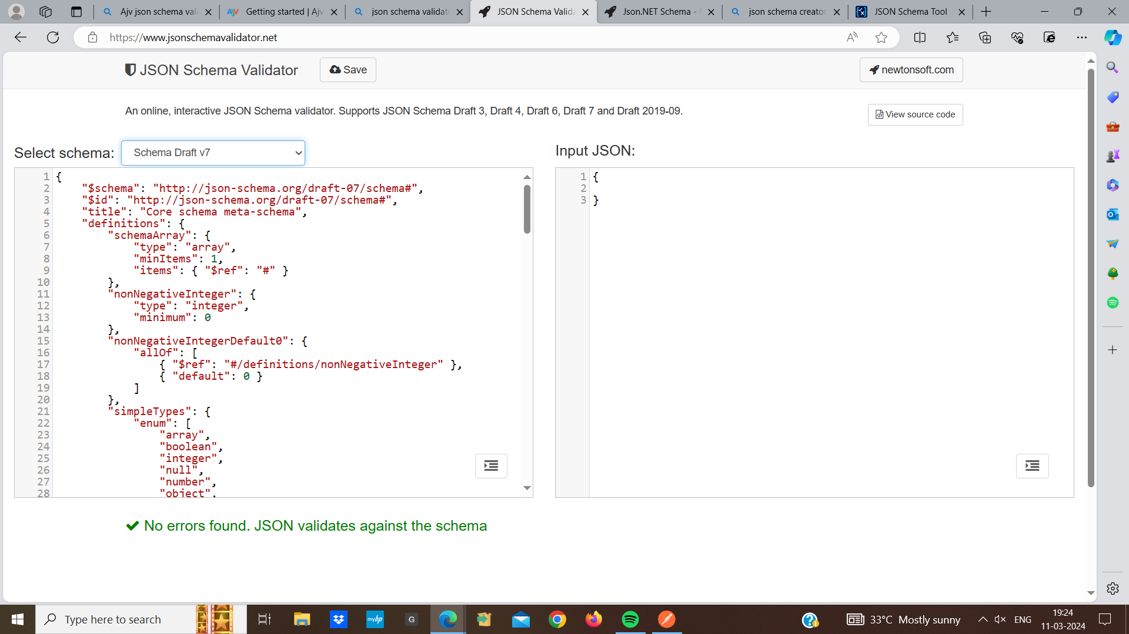

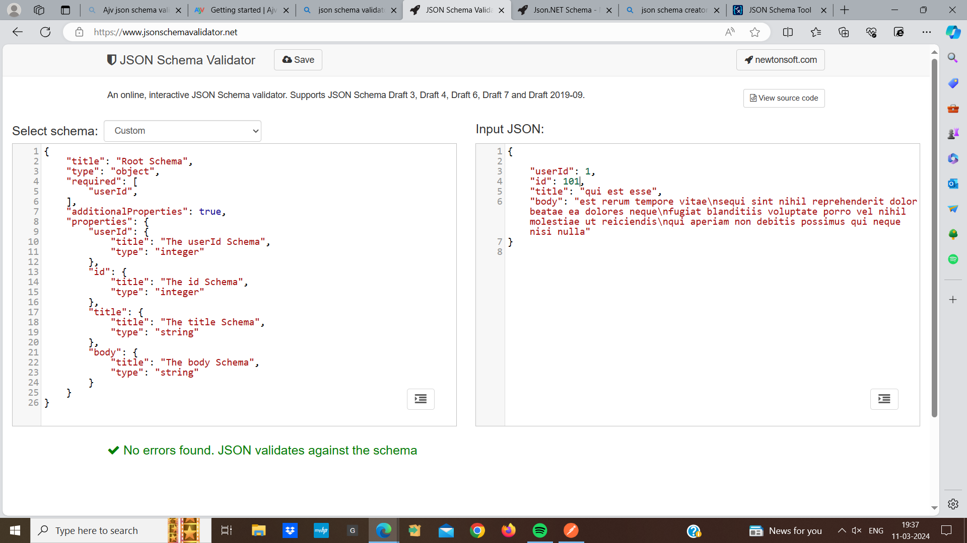

* This is our JSON schema copy the JSON schema code generated by the Ajv JSON schema creator
* In postman ,create a new request under the “tests” tab , use Ajv to validate the response data against the schema
* 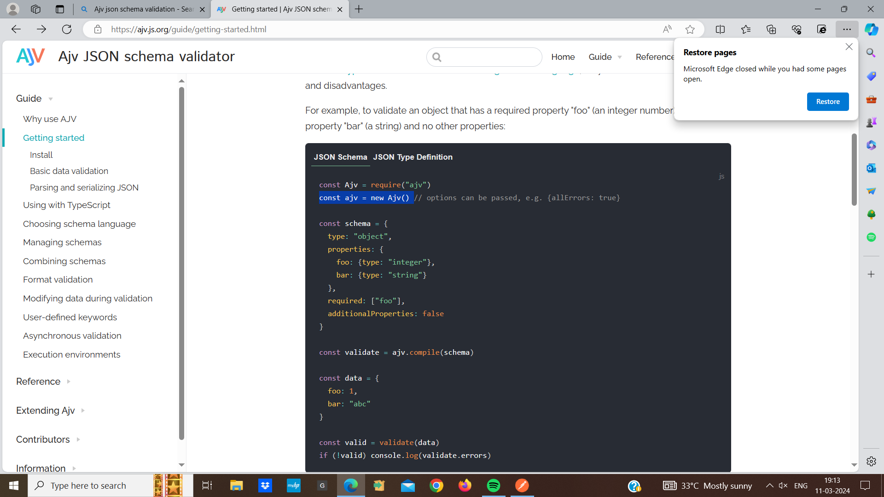

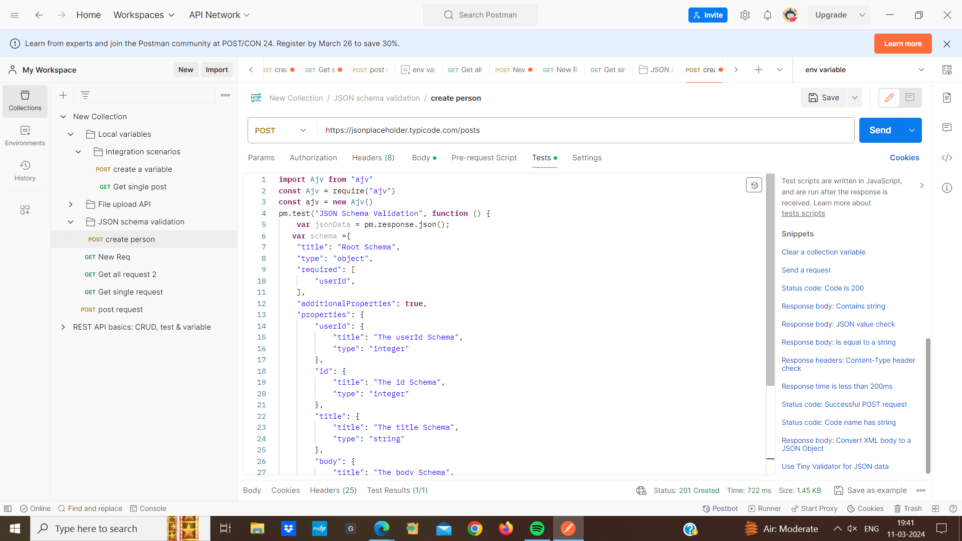

* Now, whenever we run this request in postman , the response data will be validated against the JSON schema we created using Ajv JSON schema creator.

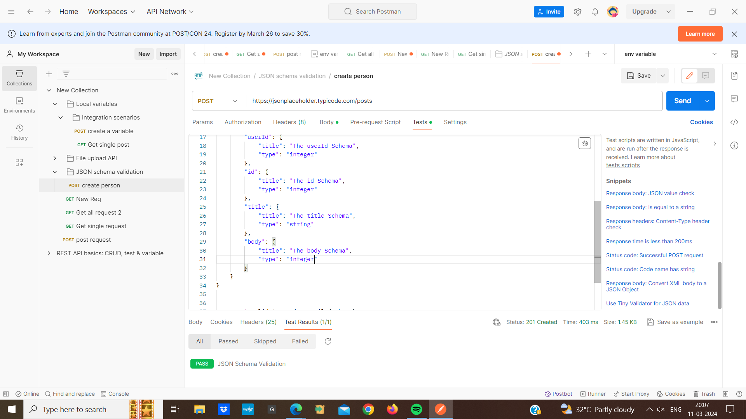

**Data Driven Testing :**

Data driven testing in postman can be accomplished by using data files such as CSV, JSON, or excel spreadsheet to provide different sets of inputs for our APIs requests

* First we create a CSV file containing our test data. Each row represents a set of inputs for our API request and each column represents a different parameter.
* for example :we have a CSV file named testdata.csv

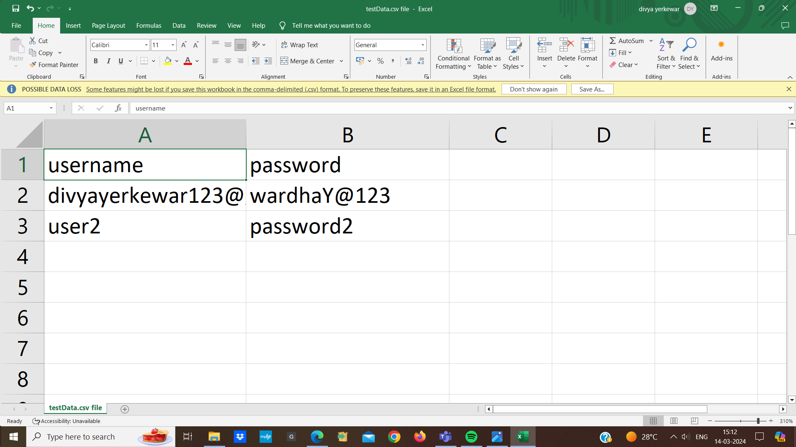

* then we create a collection and within the collection we create a new request for the API endpoint we want to test.
* we run the folder and click on th “upload files” button and select the CSV file
* postman will automatically parse the CSV file and make the data available for use in our requests.

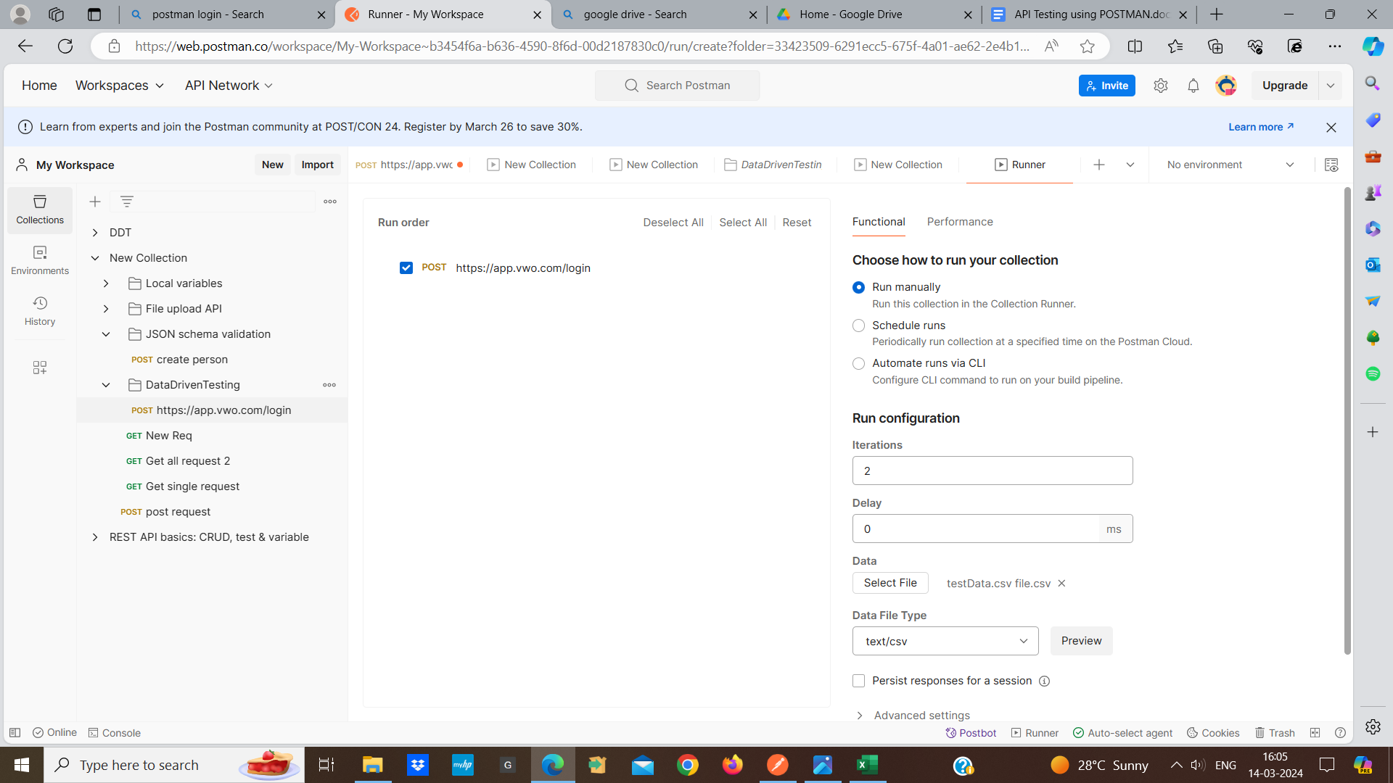

* Go to the “tests” tab of our request and write javascript to iterate over each row of the CSV file and send the request
* In the collection or request runner ,select the data file wwe uploaded
* click on the run button to execute the request with each row of data from the CSV file
* postman will execute the request for each row of data

for ex:

: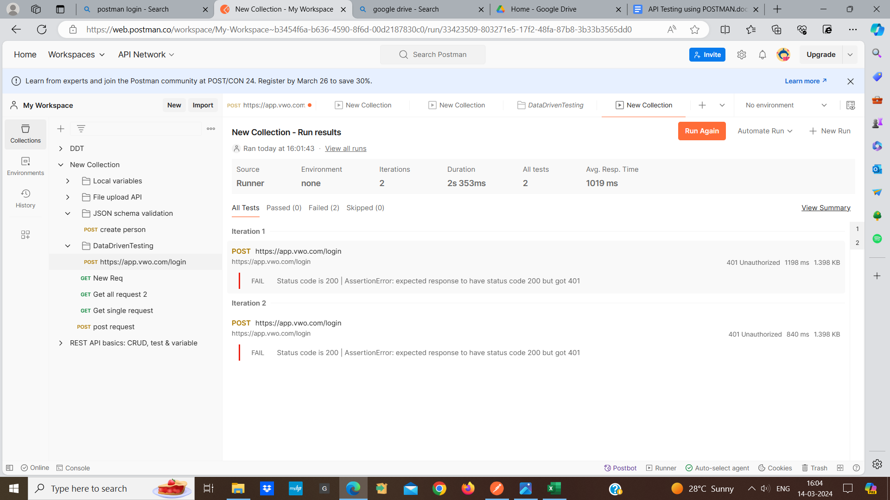

**API monitoring:** API monitoring in postman refers to the process of continuously checking the availability ,performance, and functionality of our APIs. Postman provides a feature called “monitors” that allows us to automate the execution of APIs requests and monitor their responses.

How API monitors work:

* first we create a new collection named “Run daily”
* Then we add a GET request named the request “ping scroll test”. set the request URL to our API endpoint(e.g scrolltest.com)
* choose the GET method
* Go to the “tests” tab for the “ping scroll test” request.
* Add a test to verify the response status code is 200:

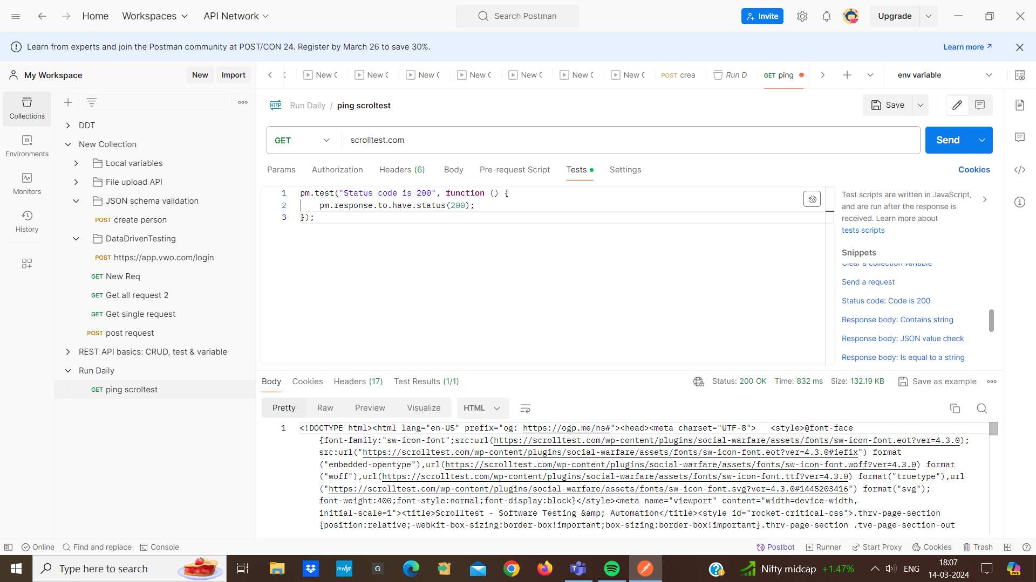

* click on the “run daily” collection and click on the “new monitor” button

configure the monitor setting such as monitor name,frequency, notification

click on the “Run monitor”button to start the monitoring process.

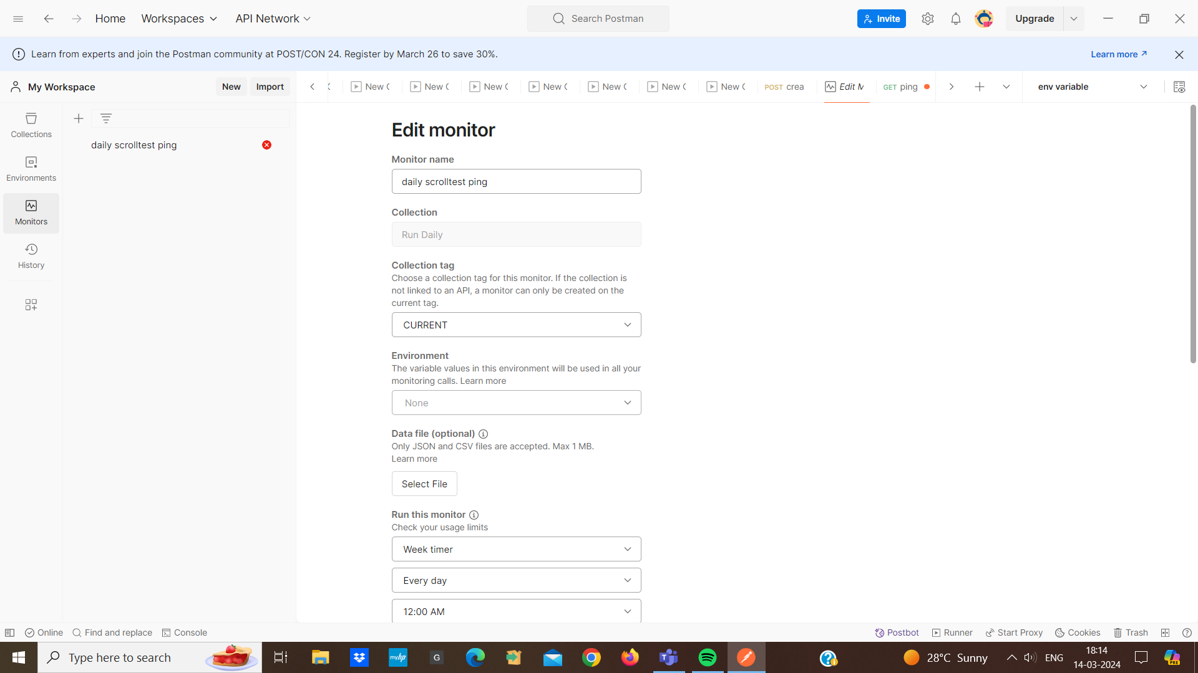

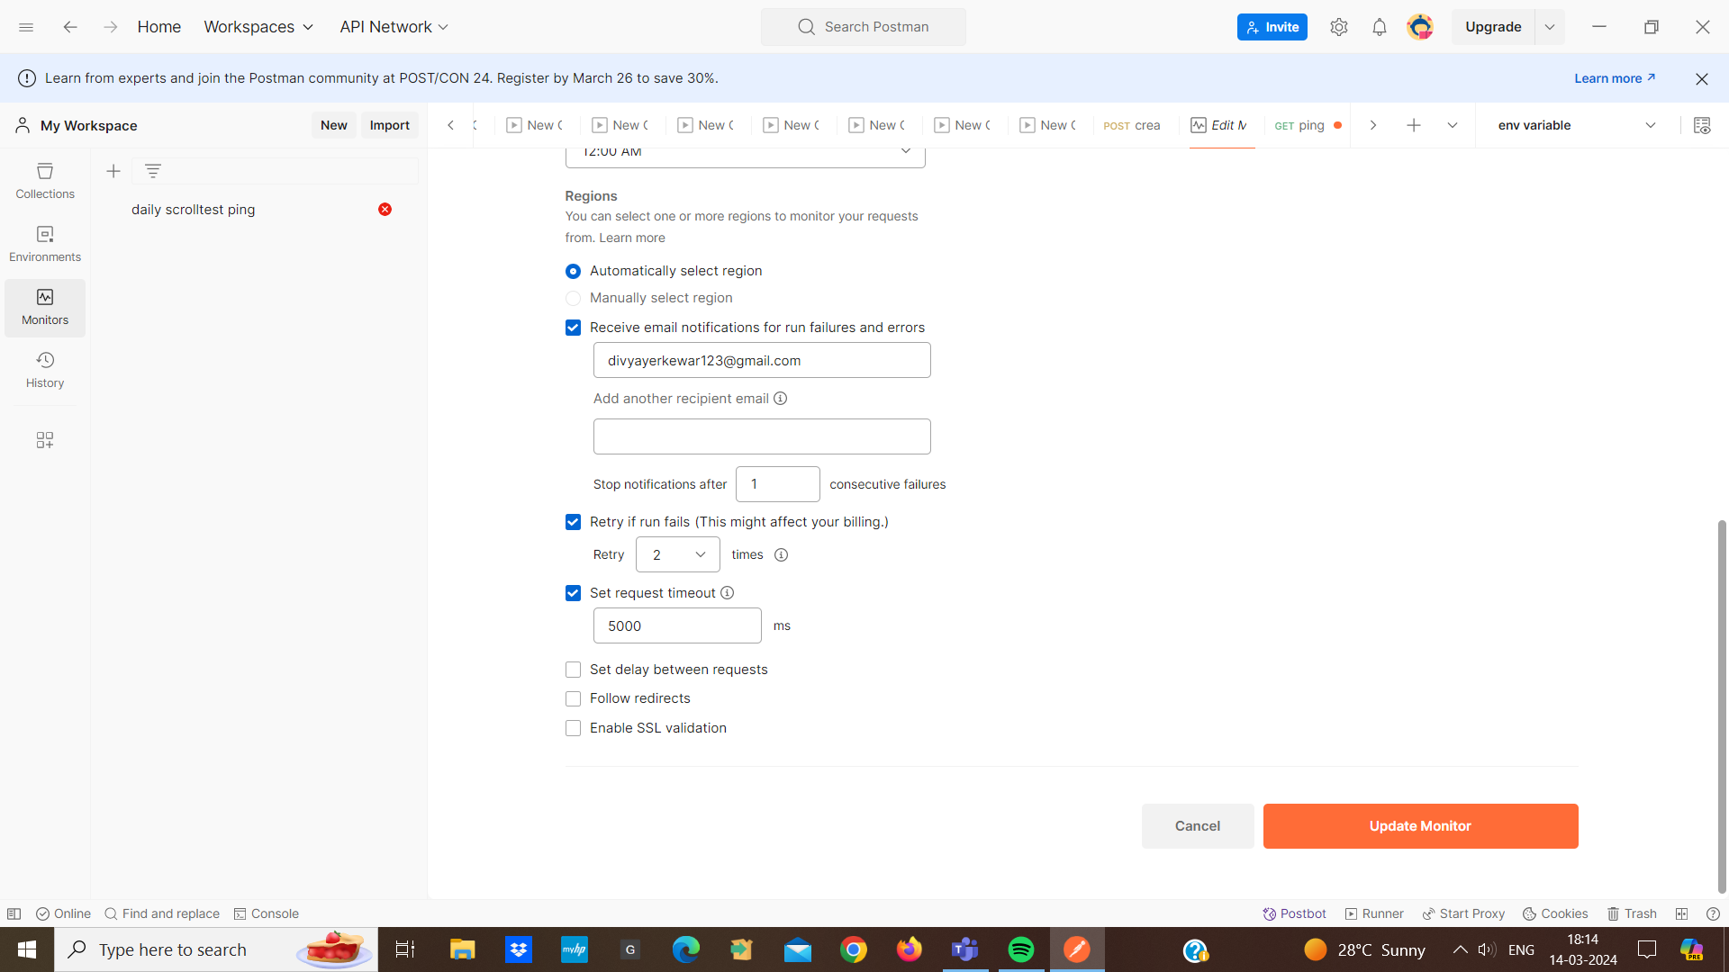

* This is our response:

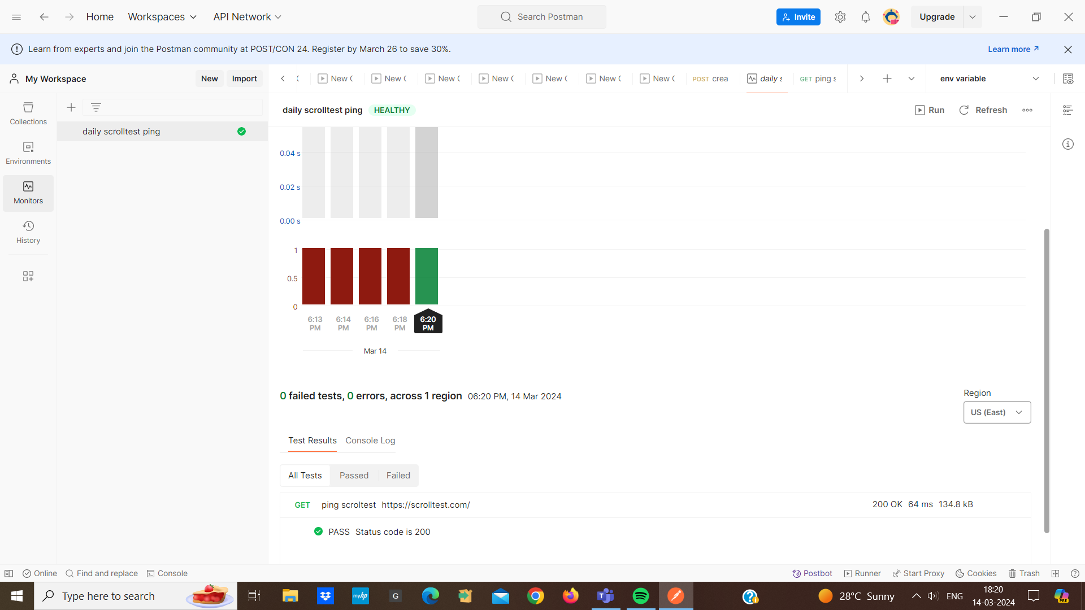

if we need to edit the monitor setting after its been created , we can do so by clicking on the “edit” button

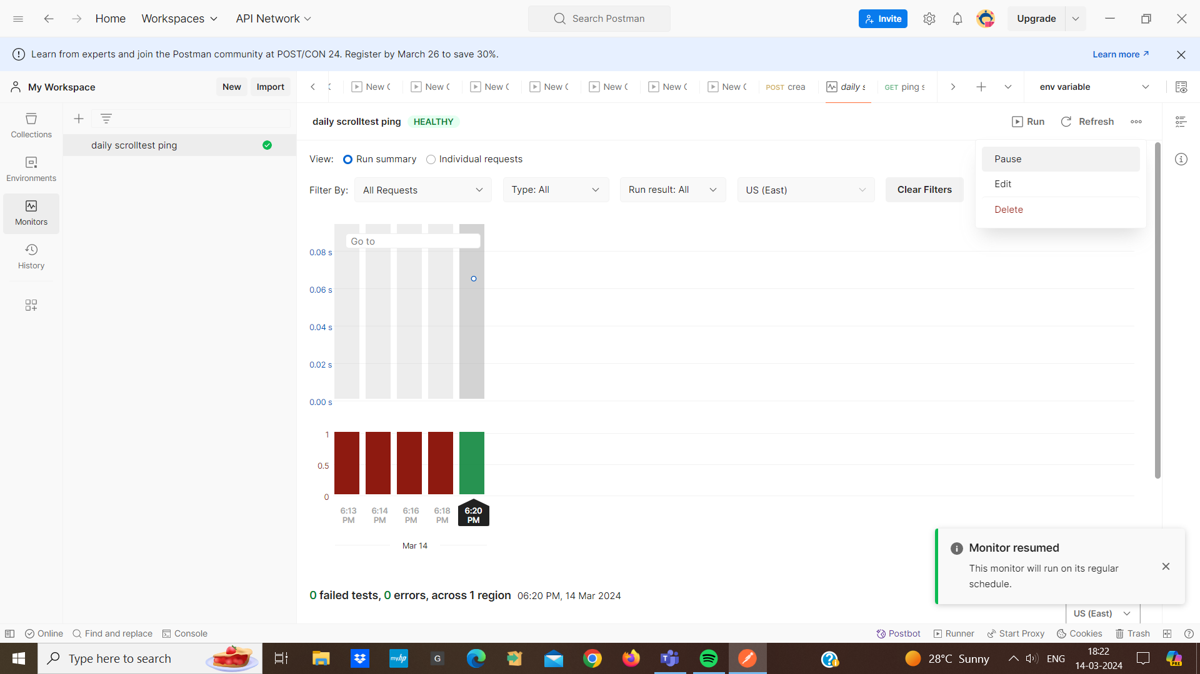

**Mock server in postman:**

* A mock server in postman is a feature tool that lets developers create virtual endpoints with fake responses. This means we can simulate how an API would behave without actually having to build the entire backend system.
* A mock server helps developers test their code and make sure everything works as expected.
* when you are building an application that needs to interact with an API.
* we usually need the actual API to be up and running for testing
* we want to test how our app behaves in different scenario without relying on the real API
* we can simulate different scenario, like what happens if the API returns an error

**For example:**

1. First we create a new collection and name it “mock server collection” .
2. Click on the “add request”button and name the request “Get Users” and choose the get method.
3. Then we create a mock server and specify the request method, response body and response code :

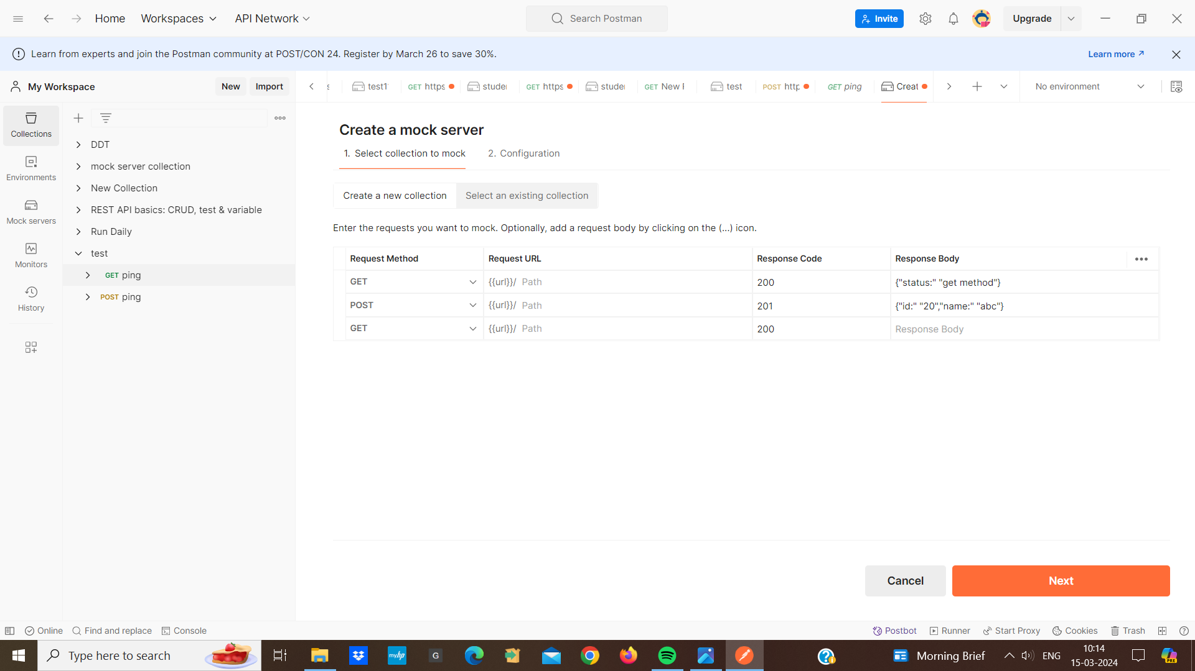

1. Name the mock server “test 1” and add the environment from the dropdown list and click on create

a mock server.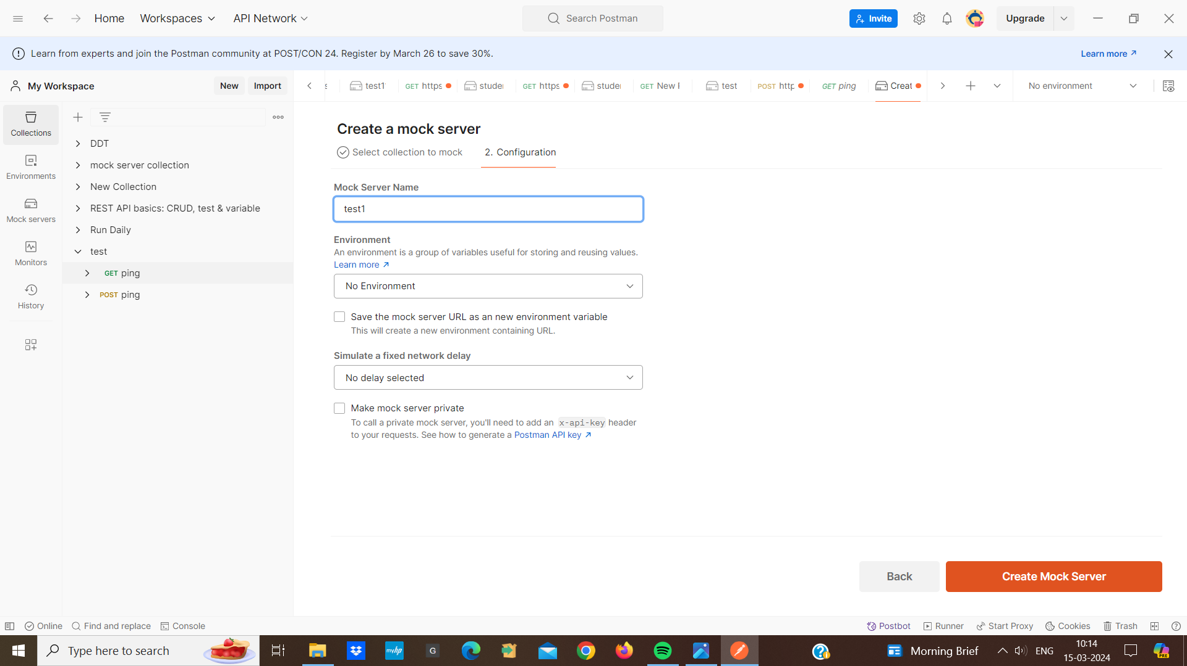

1. postman will provide us with a base URL for our responses:

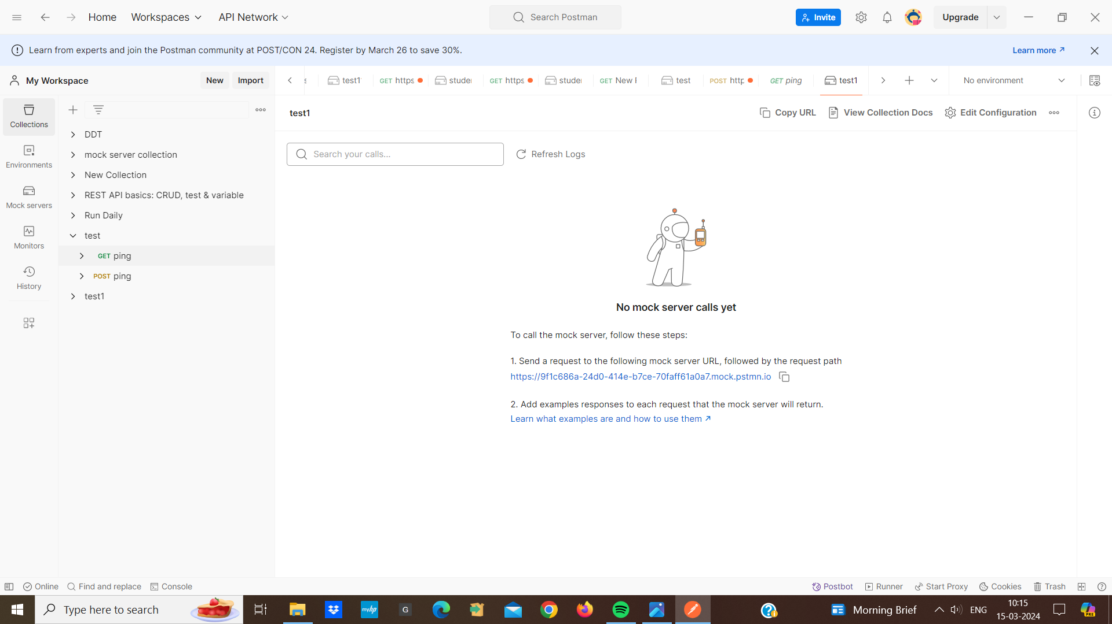

1. Use the base URL provided by the postman to make requests to our mock server.
2. Send a GET to the endpoint using the base URL
3. Postman will return the configured mock response

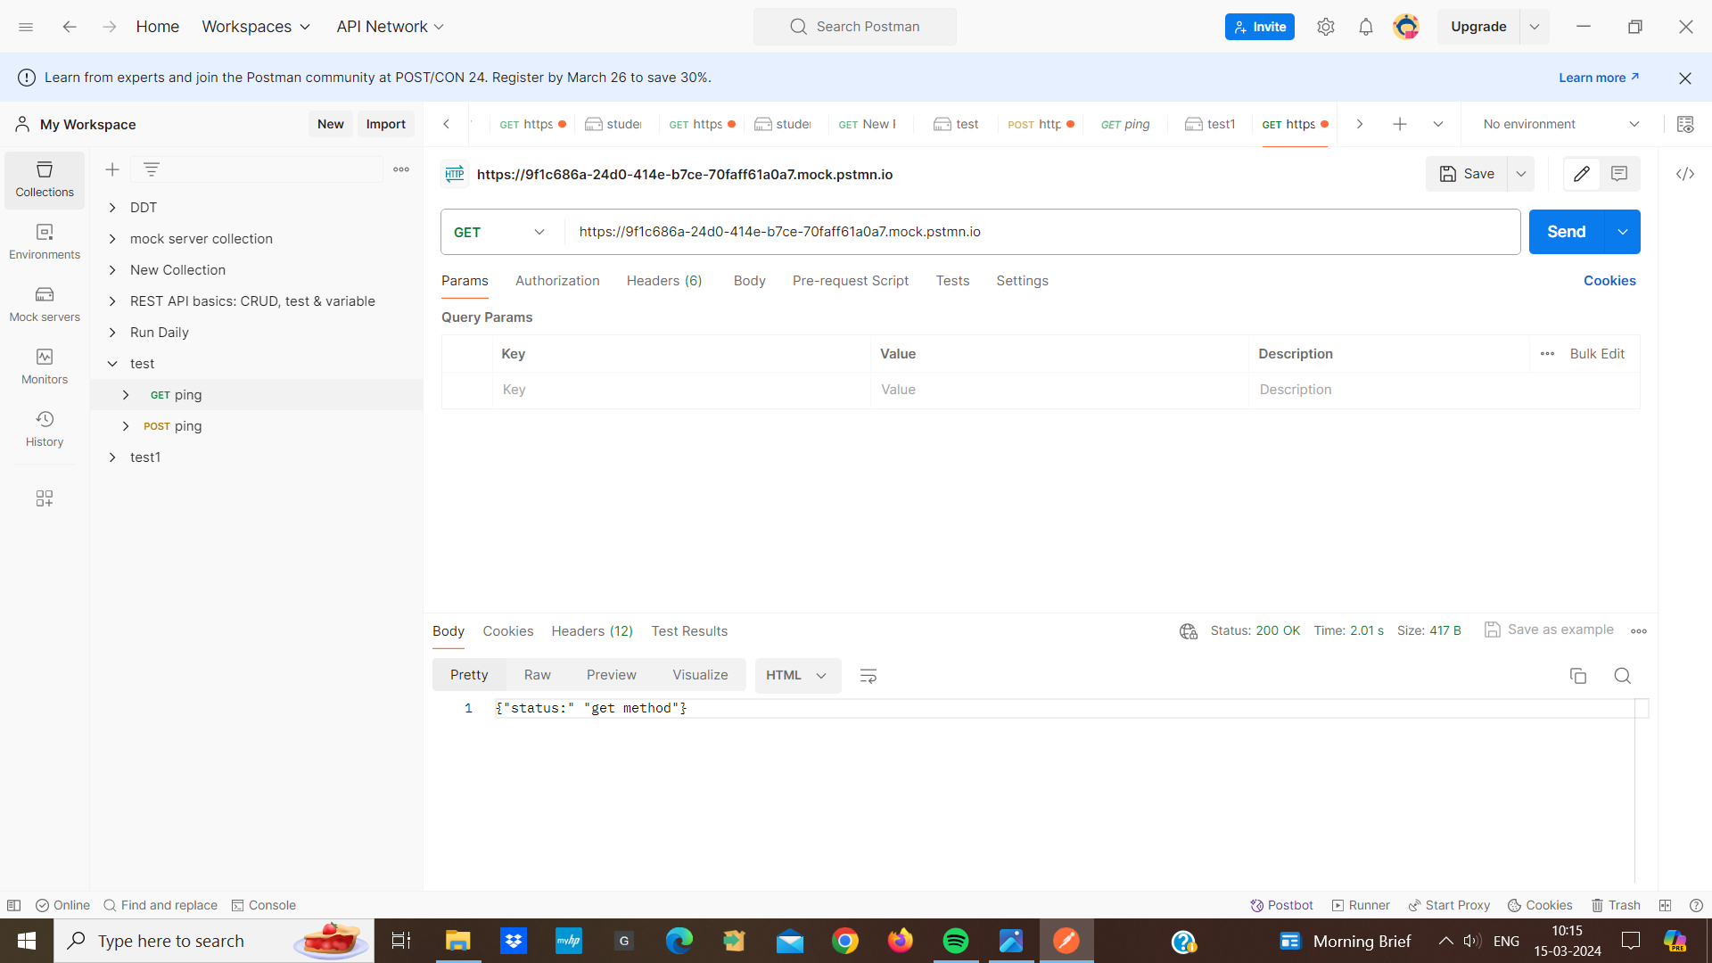

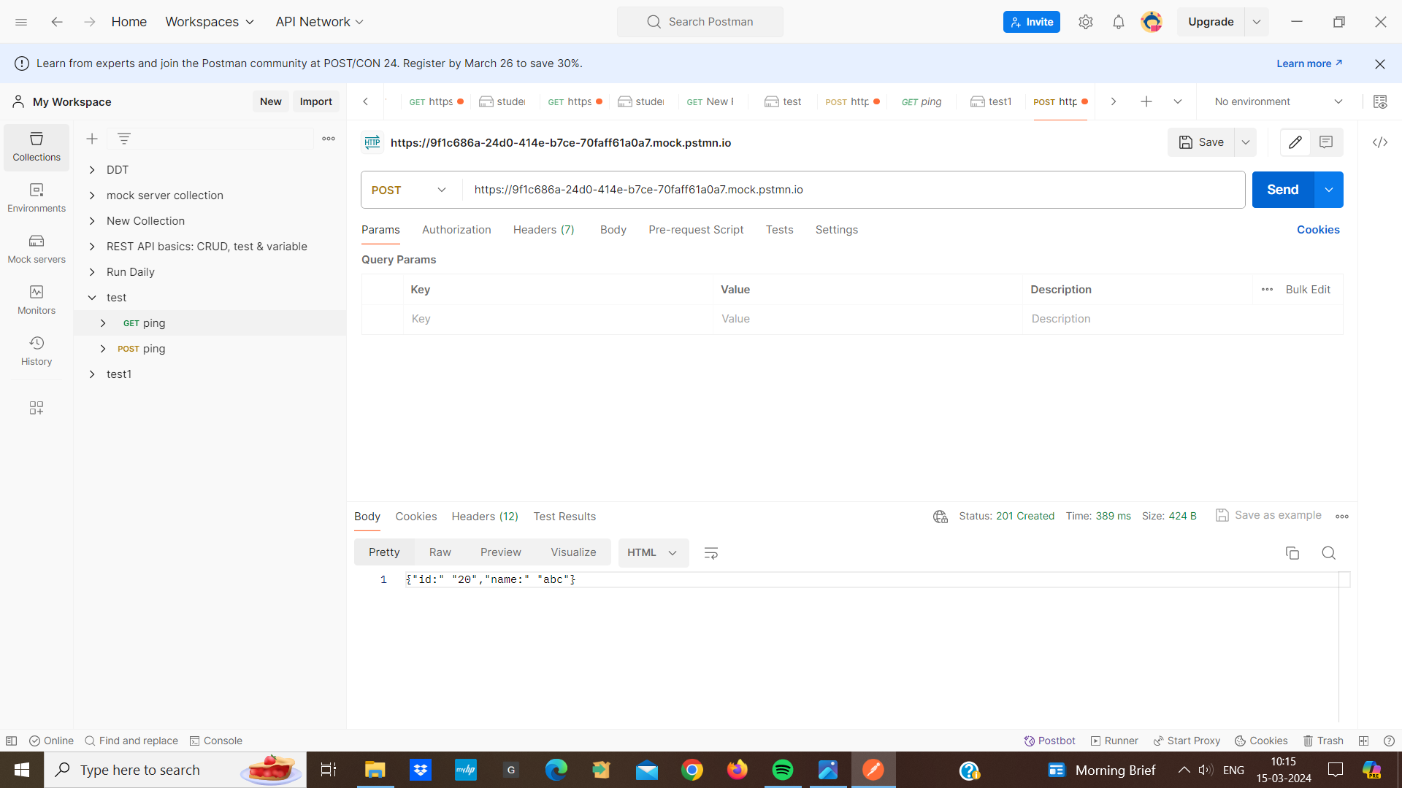

1. If we no longer need the mock server, we can delete it by clicking on the “Delete Server” button.

**Git:**

Git is a version control system that helps us manage and keep track of changes to our files. This makes it easy to collaborate with others, revert to the previous version if something goes wrong .

**GitHub:**

GitHub is a website and service where we can share our files with team and friends. we can all work on the same project together, see what changes have been made and even discuss about the work we are doing its as a platform where we can store our git repositories and collaborate with others.Imagine we have a group project and everyone can contribute to the project and see each others changes. It provides features like issue tracking to help teams work together.

**Newman postman :**

Newman is a command line collection runner for postman. It allows us to run our postman collection directly from the command line interface without needing to open the postman app. Newman is useful for automating API testing, running tests in continuous integration. just by typing a few commands into our computer’s command prompt.

**API Testing using Newman tool:**

1. First we open the postman tool and navigate to the collection we want to test and choose the collection and click on the “Export” button. Then we choose the format (e.g JSON) and save the exported collection file to our local machine.
2. we open our command prompt and run the command “npm install -g newman” to install Newman globally on our system
3. Then to run our postman collection with newman we navigate to the directory where our postman collection file is located. And run the command “newman run collection.json”.

for ex : newman run collection.json

1. Then it will display the test results in our command prompt. Newman provides the results of the number of requests executed, assertions passed or failed and the total run time and average response time.

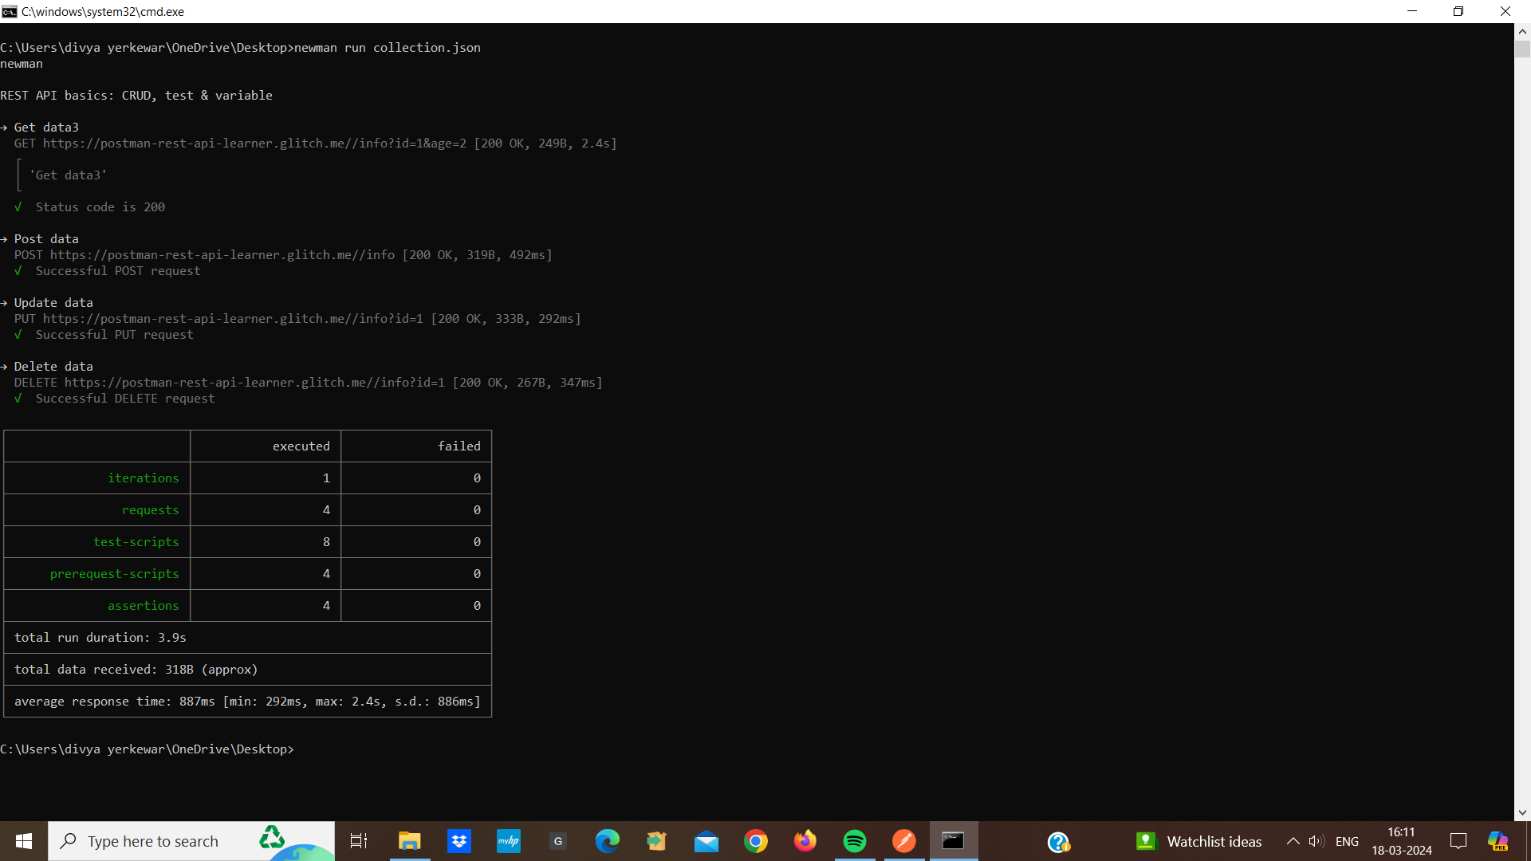

**Newman HTML reporter :**

* Newwan HTML reporter is a tool that helps us to create and organize reports after running our API tests using newman.
* When we run our postman collections using newman, it generates detailed reports of the tests run results in HTML format.
* These reports include information such as request, assertions, test case failed, passes.
* To create a postman collection report using a newman HTML reporter.
* First we install newman globally using npm the command is “npm install -g newman”
* We export our collection on a local machine.
* Then we run our postman collection using newman

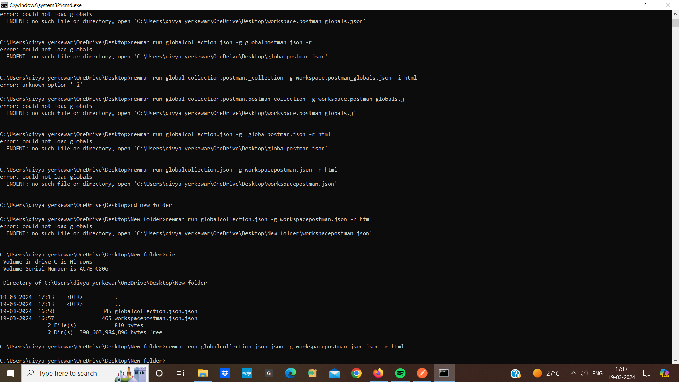

* Newman will generate an HTML report by default.

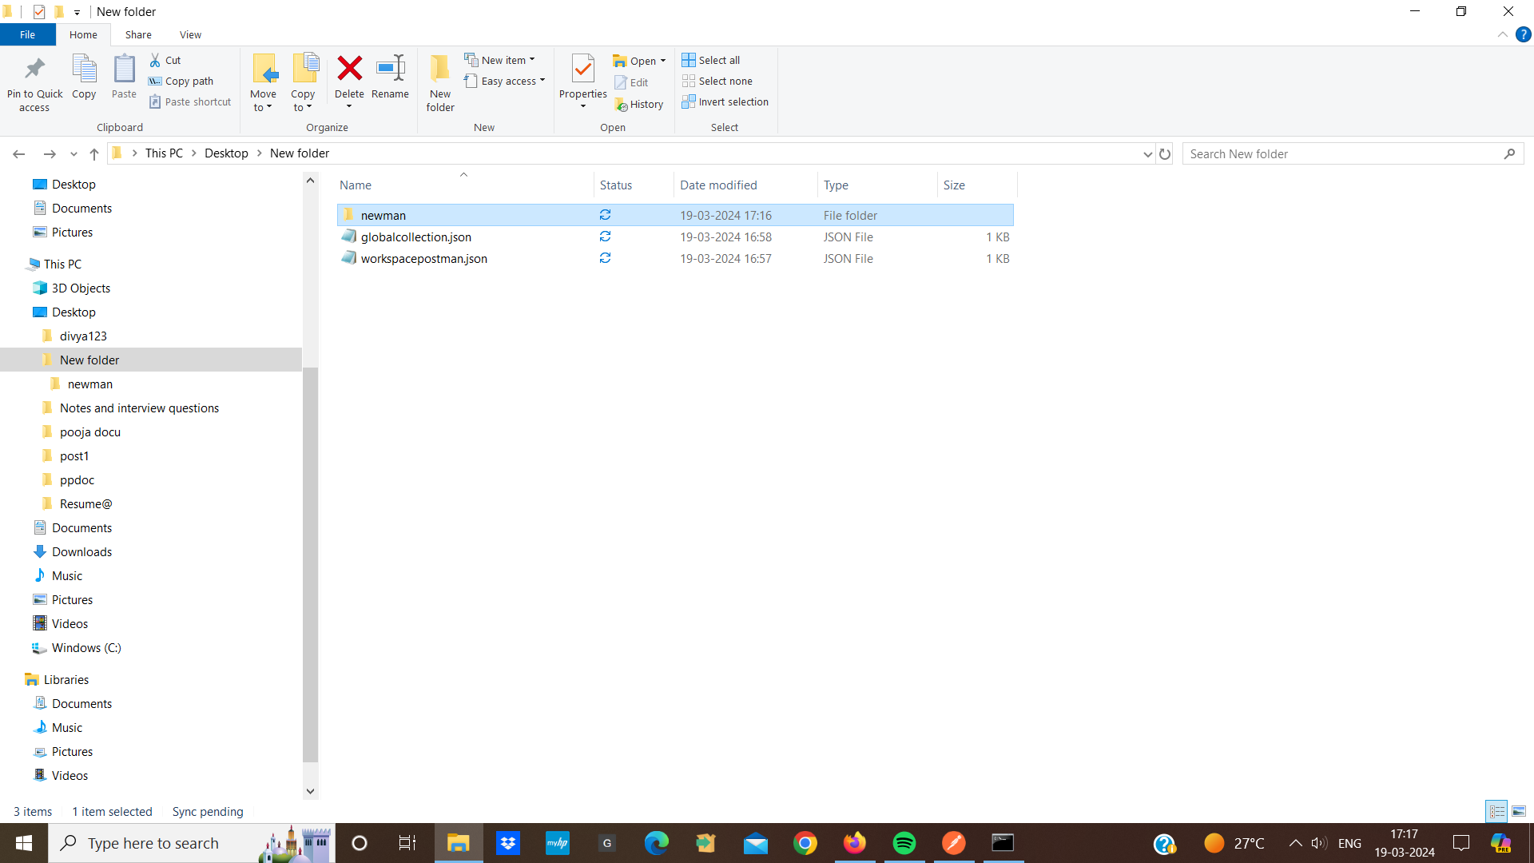

* This is our postman collection report using a newman HTML reporter.

